

Handbook

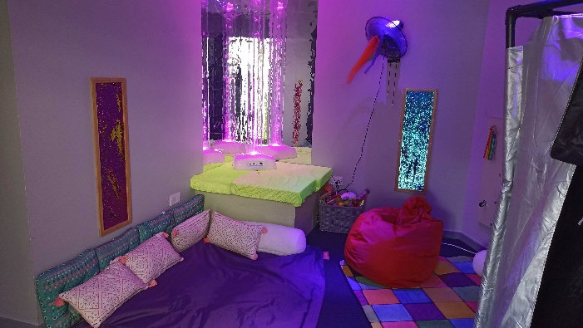
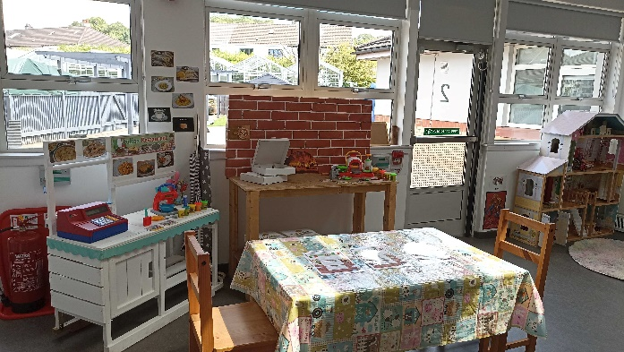

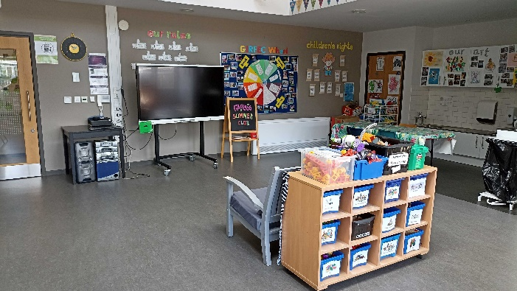
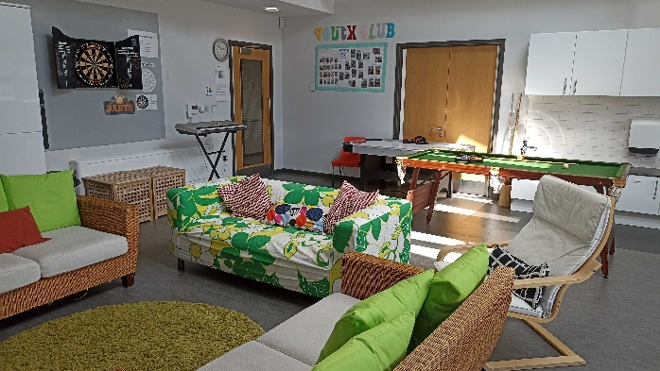

Buddies Clubs and Services
190 Southbrae Drive
Glasgow
G13 1TX
Tel 0141 434 0201/Fax 0141 434 0410
Email buddies@buddiesglasgow.org.uk

Charity No SC024503

  It should be noted that children at play are not playing about;
  Their games should be seen as their most serious minded activity

Mission Statement

“Buddies provides community based play/leisure, social and recreational opportunities for range of children and young people with additional support, giving independence, choice and the opportunity to be valued as individuals allowing children and families to lead as normal lives as possible”.

Buddies Clubs and Services
Buddies Clubs and Services is a recognised charity and a company limited by guarantee.
We totally rely on outside funding through various grants, trust funds Staff fundraising and income from fees.
We are a voluntary organisation run by a Board of Directors comprising of mainly Parents.
We are able to offer a variety of services to families including:
Youth Club, Sunday Club, after school, Nursery,
Positive parenting courses, Play Schemes and Outreach and Creative Breaks.

Aims
- To develop each child/young person’s self esteem

- To empower each child/young person to explore/develop new skills

- Encourage the development of interpersonal skills

- Develop concentration and listening skills

- Develop communication skills (including signing)

- Encourage independence skills

- To participate and enjoy all activities

- To develop and sustain positive relationships and friendships

Our Staff
We have a large team of experienced Support workers who have training in a variety of areas such as:
SVQ Children and Young People, First Aid, Health and Safety, Administration of prescribed medicines and many more to enable them to meet the individual needs of the children. However, our staff have no formal medical training other than that given by parents or school nurses. We do not have an in-house Registered Nurse.

Admissions & Discharge
Children come our way variously: self-referral via parents; referrals from SEN schools via teachers; through educational psychologists, health visitors, social workers. An information pack is sent to the source for completion. Initial contact is made by inviting parent / carer to Buddies to have a discussion. Following this a Buddies visit is arranged for the child. This is to allow staff to observe the child in the play environment. Senior staff must take into consideration suitable days and level of support needed, available funding and the mix of children. A further visit, into suitable group may be arranged.
If deemed appropriate, to gain more information, a senior member of staff may carry out a school visit in the early stages of assessment or trial period.
For children to access the service parents must become members of Buddies clubs and services Scheme. Annual membership is £6.00 per family, £3.00 for a single parent family. Contact with families is kept up; including regular monitoring and evaluation questionnaires, to ensure the service meets individual needs.

Discharge
Normally children who are happy and able to benefit from Buddies remain within the service according to need and funding. Should a child experience difficulties or not settle, a full discussion is held with the referral source and parent with the aid of written reports. Occasionally Buddies simply cannot accept a child because of the high level of support needed or because some serious health issue is incompatible with our insurance cover. Our management team have the right to review placements when circumstances and events pose a potential risk to other children / teens or staff, in line with Buddies health and safety policy and risk assessments.

Administering Medication
Children at Buddies present a range of health issues. Where feasible we give staff training in how to manage this. However, children whose conditions have more serious implications (e.g. those needing injections) training would have to be looked at for staff to be able to provide a service for the young person. Our insurance cover permits us to administer prescribed medication. Parents sign consent forms agreeing to this and provide full details of drug, dosage etc. Medication forms are taken out when on trips and outings for children and young adults who take medication, all staff are updated regularly on the medication policy. Buddies have a locked medicine cabinet and double signatures are required in handing out children’s medication. Staff are trained to administer various prescribed medicine. Staff training is updated on a regular basis to ensure all existing and new children’s medical needs are being met.

Board of Directors
The Articles of Association of the Company require a minimum membership of two, with a maximum of fifteen. At least two thirds of the membership must be parents or guardians of persons who participate in our activities. The quorum at any board Meeting must be at least fifty percent of current membership. No paid employee may be a Board Member. The Board is responsible for every aspect of our activities, existing or new. One very important aspect is the continuing efforts to obtain sufficient financial support via local government sources, various charitable trusts and staff fund raising etc. We can never be self supporting. Under company law and other various Statutes, this includes for example:

1. | Maintenance of proper accounting records, which disclose at any time the current financial position of the company and facilitate compliance with the Companies Act.
2. | Safeguarding the Company assets
3. | Adherence to all applicable current legislation – Employment Laws, Health & Safety etc
4. | Maintenance of proper Minutes of all Board and General Meetings
5. | Circulation of Annual Accounts to all Company members and convening an Annual General Meeting of members each year

Day to Day Management

1 | The Service Manager is responsibility for the day to day implementation and improvement of our activities, assisted by our full/part time staff
2 | Detailed reports are made to the Board at each meeting
3 | All other decisions being taken at Board meetings

Communication systems
We use Board maker symbols as pictorial aids for the children; some children have individual boards and books. This is a vital means of communication for children with little or no speech and language. Staff has an awareness of Makaton (signing system). We feel strongly that children should be encouraged to express themselves through either verbal/non-verbal Communication systems. We encourage Parents to inform us of any changes regarding communication
Systems.

Challenging Behaviour
As a parent-led organisation we are opposed to physical intervention. The only time we find this necessary is when a child is either a) self-injury, b) threatening to injure another child or staff member. We use de-escalation techniques and redirection to defuse these situations however,

Child/ Adult Safeguarding
We carry out PVG checks on all staff and volunteers through Disclosure Scotland. This procedure is carried out prior to employment commencing. Part of our Child Protection Policy relates to photographs and videos. Photographs will only be taken with parental consent. Parents are not allowed to take pictures or use videos within Buddies for personal use. All staff has regular training and updates relating to Child Protection.

Confidentiality
Information about children is given by parents/carers during registration and some of this may be confidential. A personal child care plan is completed by the parent/carer. These profiles are used by staff as a guide to the child’s needs. Information is not confidential, but contains helpful facts like ‘afraid of dogs’, ‘allergic to dairy food’ etc. This information is then put into a passport for each individual child/young adult which are updated regularly. Personal information from outside sources - e.g. confidential background on child/family circumstances - is kept in separate secure files. This is not available to anyone apart from the data protection Officer and the processor unless child abuse is suspected, when we must by law assist all concerned.

Due to the Data Protection Act only names, addresses and phone numbers are on computer, along with contact numbers for emergencies or social workers. We do not keep large screeds of information on file. Most of what we do keep is a help to caring for the children safely and constructively all information is marked Confidential if required and access is controlled.
Our photocopying is limited to personal profiles for use by staff and consent forms signed by parents as required by law. No other information is copied.
Help should always be offered with completing forms. Social workers making referrals are asked to assist with forms to optimise use of Buddies services. For instance, if a child is terrified of dogs we need to know because an outing to the park could need a 1:1 staff ratio or might involve a risk assessment. All such issues affect the staff levels needed and their efficient use. Buddies will not pass personal details to other professionals without parental knowledge or consent. Parents have access to all records concerning their child.

Consent Forms
Consent forms are completed on an annual basis by parents/carers. We require an emergency contact number in case of an accident or emergency where the parent/career cannot be contacted. Please keep the office upto date with new information and contact numbers.

Healthy Eating
Healthy eating is a very important to both children and families who use our services. Many of our children suffer from various allergies to additives and a small number have peanut allergies.

Snack-time:
We provide children with a variety of fresh fruit such as grapes, bananas and either milk or water. We also try to offer the children with variety and encourage experimentation – rice cakes and breadsticks are popular with the younger ones! They love carrot and cucumber sticks and fresh yoghurt also!

Lunches: (Holiday Clubs)
We now offer lunches for the children who attend holiday club taking into consideration dietary requirements. This consists of sandwich, fruit and drink.

Security
Buddies have a secured entrance controlled by a monitor in the office and playrooms. Only a named person will be allowed to collect a child from Buddies. It is essential that parents/carers inform the office/management if someone different is collecting their child.
Fire door and escapes are clearly marked with fire drills carried out announced and unannounced on a regular basis.

Settling in

When a child is allocated a place, there is a settling in policy. Children attend for 1 hour on first day and the parent/carer stays either with child or on premises (depending ever is deemed appropriate). Following a number of visits or once a child is happy and settled parent/carers are able to leave. This process may take longer for some children. All necessary paperwork will have been completed by this stage.

Sickness/Respite
We would appreciate as much notice as possible due to staff ratios.
Website
We have our own website which has more information on all our services and is updated regularly with new information
Buddiesglasgow.org.uk

Services
Cancellation – Parents should be aware that in the event of late staff sickness cancellation of a service may occur.
If a Parent/Carer wishes to cancel we require 24 hours notice or charges will apply
(Please note that we staff for the number of children we expect for each service)
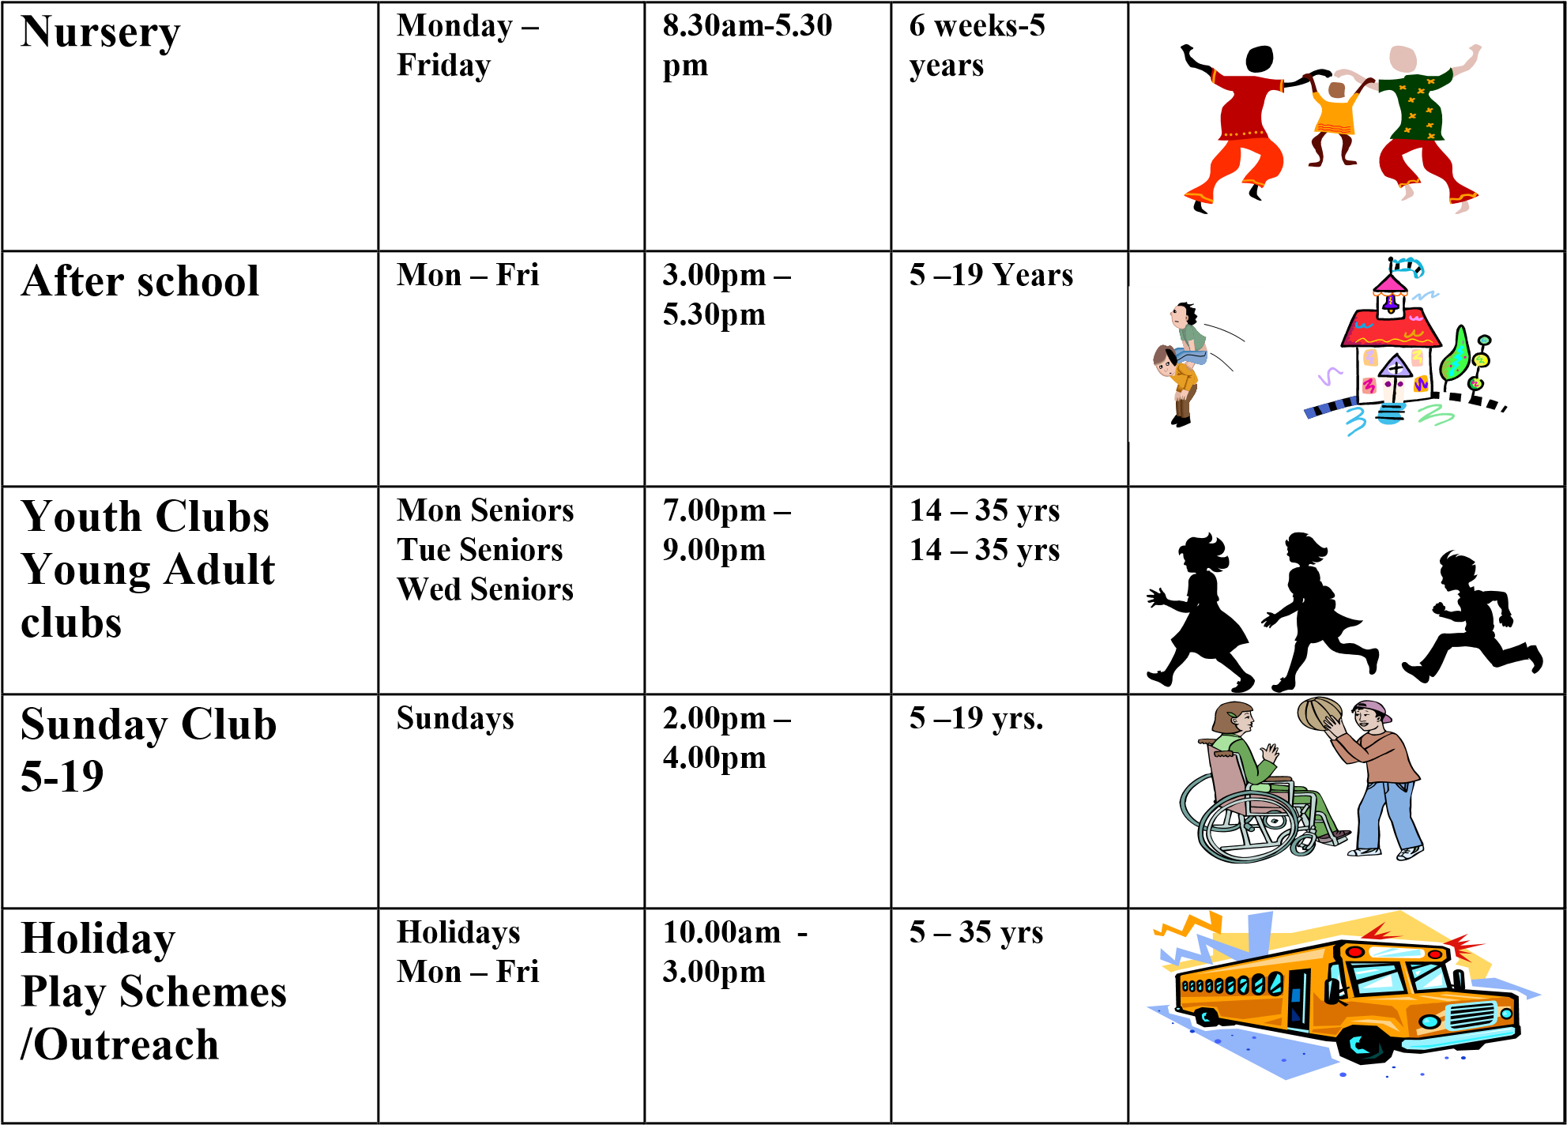

10.30-12.30
&
2pm – 4pm

Care Inspectorate
We are regulated by the Care Inspectorate who carries out Annual Inspections. A copy of these are available to read on the Parent’s Notice Board next to the main entrance of Buddies.

Complaints & Suggestions

We welcome any complaints / suggestions to help us improve our service.
Initial complaints should be made to the Manager
You will be informed of the action taken (if any) within 20 days after the date on which the complaint was made.
However parents are free at any time to complain directly to;

Care Inspectorate
Compass House
11 Riverside Drive Dundee
DD1 4NY Tel; 013820207200

Fundraising, Donations and Grants:

BUDDIES CLUB IS A PARENT LED ORGANISATION.
We are a voluntary organization, a recognized Scottish charity and a company limited by guarantee. All parents are invited to become members. Annual membership costs £6.00 per family /£3.00 for a single parent.

WE CONSTANTLY FUND RAISE TO PROVIDE, EQUIPMENT, OUTINGS, SUBSIDISED PLACEMENTS IN ALL SERVICES AND EXTRA STAFF TO SUPPORT CHILDREN AND FAMILIES.

All parents are invited to fundraising events and your support is greatly appreciated.

We receive a range of grants to assist with different services. All grants are acknowledged in our annual accounts under the relevant restricted funding section.

